**lPredict Scaffold: Practice Questions and Planning**

Step 1: Determine the types of prediction you need to make. Highlight this in the question and annotate. If there are multiple components in the question, number them.

Question: EDITED FROM PREVIOUS EXAM 2020 MC 15 **(4.1.5 a)**

In watermelon, skin colour is controlled by a single autosomal gene. The two phenotypic variants are green and striped. Two plants, one homozygous for the green alleles, and one homozygous for the striped alleles, were crossed. The figure shows the phenotypic frequency for the initial (F0) generation and the subsequent (F1) generation.

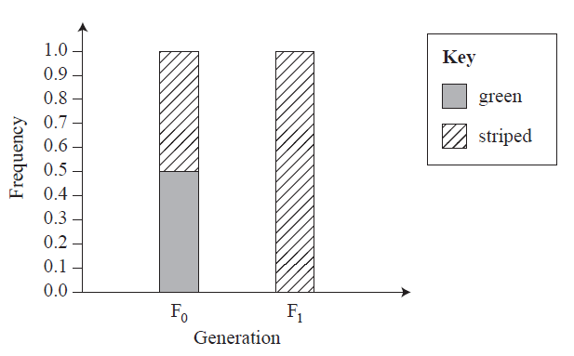

A cross was then performed between members of the F1 generation. Predict the next generation’s genotype and phenotype frequency. Which type of inheritance pattern is represented here? [3 marks]

|  |  |  |
| --- | --- | --- |
| Information available to inform a prediction or help figure out what will happen | Expected result of an upcoming action or event | How the available information supports this |
| 1. Phenotypic and genotypic frequencies of the F0 (P1) generation 2. Phenotypic ration of the F1 3. Deduce the genotypic frequencies of the F1 generation from those of the F0 and their phenotype |  | Use a punnet square to predict genotypic and phenotypic ratios |

Step 2: Identify available information which can be used to give an expected result of an upcoming action or event or to suggest what may happen based on the information

Step 3: Consider how you will communicate your evaluation with your audience. Write your prediction:

F2 Generation

Genotypic frequency:

Homozygous dominant SS 25%

Heterozygous Ss 50%

Homozygous recessive ss 25%

Phenotypic frequency:

Striped watermelon = 75% Green watermelon = 25%

This is an Autosomal Dominant Trait.

The following pedigree shows the inheritance of Duchenne muscular dystrophy. The fully shaded individuals have the disease. **(4.1.5 a)**

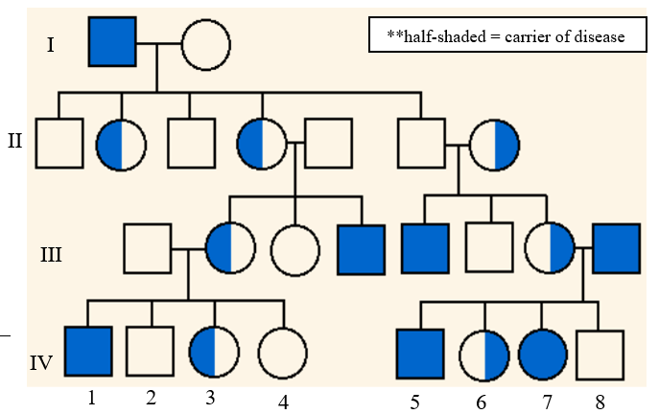

1. Deduce the inheritance pattern for Duchenne muscular dystrophy.

It appears to show a ‘sex-linked recessive’ pattern of inheritance.

This conclusion is supported by the fact that all the individuals shown are carriers and therefore heterozygous are female while all but one (individual number 7) of those showing the disease in their phenotype are male. This is very unlikely if the disease was not ‘sex-linked’.

1. If individuals 6 and 1 have children, predict the genotypic and phenotypic frequencies of the resulting offspring?

P1 generation phenotypes = Female 6 - XD Xd + Male 1 - Xd Y X D= Dominant Normal allele

X d= Duchenne allele

Potential gametes= XD, Xd + Xd, Y

Punnett Square =

|  |  |  |
| --- | --- | --- |
|  | XD | Xd |
| Xd | XD Xd | Xd Xd |
| Y | XD Y | Xd Y |

Genotypic frequencies:

Heterozygous female XD Xd = ¼ or 25%

Homozygous recessive female Xd Xd = ¼ or 25%

Hemizygous recessive male Xd Y = ¼ or 25%

Hemizygous Dominant male XD Y = ¼ or 25%

Phenotypic frequencies:

Normal female = ¼ or 25%

Female with Duchenne muscular dystrophy = ¼ or 25%

Male with Duchenne muscular dystrophy = ¼ or 25%

Normal male = ¼ or 25%